Document ID: ${DocumentId} ●Title: ${Document_title}
Revision: ${Version} ● Date of effectiveness: ${Published_date}

 | Name | Function | Digitally Signed
Author | ${Author1_N/A} | ${Author_function1_N/A} | ${Author_date_signed1_N/A}
Reviewer 1 | ${Reviewer1_N/A} | ${Reviewer_function1_N/A} | ${Reviewer_date_signed1_N/A}
Reviewer 2 | ${Reviewer2_N/A} | ${Reviewer_function2_N/A} | ${Reviewer_date_signed2_N/A}
Approver 1 | ${Approver1_N/A} | ${Approver_function1_N/A} | ${Approver_date_signed1_N/A}
Approver 2 | ${Approver2_N/A} | ${Approver_function2_N/A} | ${Approver_date_signed2_N/A}
Approver 3 | ${Approver3_N/A} | ${Approver_function3_N/A} | ${Approver_date_signed3_N/A}
QA | ${QA1_N/A} | ${QA_function1_N/A} | ${QA_date_signed1_N/A}

Conventions
Text written in Italics (example: RSP Core Library Software Architecture) denotes filenames of relevant documents referred from this procedure.
Text starting with a capital letter (examples: User Needs, Design Validation) denotes phases or particular important elements of a process.

Content
1 Conventions 1
2 Purpose 4
3 Scope 4
4 Definitions and acronyms 4
5 RSP Core Library Overview 5
5.1 Documentation 5
6 Configuration 6
6.1 High Level Design 6
6.2 Configuration Classes 6
6.2.1 Config 7
6.2.2 ConfigValueBase 7
6.2.3 ConfigValue 7
6.2.4 Exceptions 7
7 Networking 7
7.1 High Level Design 7
7.2 Network Classes 7
7.2.1 LibCurlWrapper 8
7.2.2 HttpRequest 8
7.2.3 HttpReponse 8
7.2.4 HttpDownload 8
7.2.5 DnsLookup 8
8 Localization 8
8.1 High Level Design 8
8.2 Localization Classes 8
8.2.1 Translation 9
8.2.2 Message ID’s 9
9 Graphical User Interface 10
9.1 GUI Terms 10
9.2 High Level Design 10
9.3 GUI Classes 12
9.3.1 Point 12
9.3.2 Rect 13
9.3.3 Color 13
9.3.4 Font 13
9.3.5 Pen 13
9.3.6 Bitmap 13
9.3.7 Canvas 13
9.3.8 Ctrl 13
9.3.9 Scene 13
9.3.10 Panel 13
9.3.11 Image 13
9.3.12 Label 13
9.3.13 Button 13
9.3.14 TouchArea 14
9.3.15 CheckBox 14
10 File System 14
10.1 File System Classes 14
10.1.1 FileSystem 15
10.1.2 FileIO 15
11 Logging 15
11.1 High Level Design 15
11.2 Logging Classes 16
11.2.1 Logger 17
11.2.2 LogStream 17
11.2.3 LogWriterInterface 17
12 Utility Classes 18
12.1 AnsiEscapeCodes 18
12.2 Nullable 18
12.3 StructElement 18
12.4 Variant 18
12.5 JSON 20
12.6 Crc32 21
12.7 Singleton 21
13 References 21
14 Attachments 21
15 Version History 21

Purpose
The purpose of this document is to document the RSP Core Library Software Architecture. The architecture description and diagrams must give the reader an understanding of the library components and how to use them.

Scope
The software architecture describes the RSP core library software and how it interfaces with other software applications using the library.
The software specified in this architecture is the version 1.0 RSP Core Library software.

Definitions and acronyms
CLI Command Line Interface, a way of interacting with a computer without using a graphical display.
OS Operating system giving fundamentals for executing programs, storing data and perform network operations.
FPS Frames per second. Term used about update frequency of the graphical user interface.
GUI Graphical User Interface
JSON JavaScript Object Notation

RSP Core Library Overview
The software library is written in C++, and hold components for use in these seven common work areas:
- Configuration
- Networking
- Localization
- GUI
- Filesystem
- Logging
- Utility Classes

Because multiple programs share a lot of code, the RSP-Core-Library have been created as an external open-source package, all developed according to IEC-62304 for use in medical device systems.
The library is available on Github as rsps/rsp-core-library.
To build the library a compiler supporting at least C++17 is required.

Documentation
All relevant documentation is contained in the repository, including:
- Development Plan
- Preliminary Risk Assessment
- Safety Classification
- Requirement Specification
- Architecture
- Risk Analysis
- Core library Development Environment
- Verification Plan
- Verification Report
- Validation Plan
- Validation Report
- Release Report

Configuration
Many applications have a use for a good configuration utility. The core library provides an extensive Config class, that can be used for runtime configuration.

High Level Design
The configuration can be updated at runtime, in the safest possible way, to avoid breaking the device by a bad configuration.
The configuration object is a key/value store, with enumerable keys defined at design time.
Every value and the entire object can have validators assigned, which are executed in case of a value being set.
The values can be all types convertible to JSON, even arrays and objects.
All keys must be given a default value at design time. The default value is used to determine the type of the value.

Configuration Classes
The Config class holds any number of ConfigValue objects. The Config object is a singleton instance, with delete possibility for automated testing support.
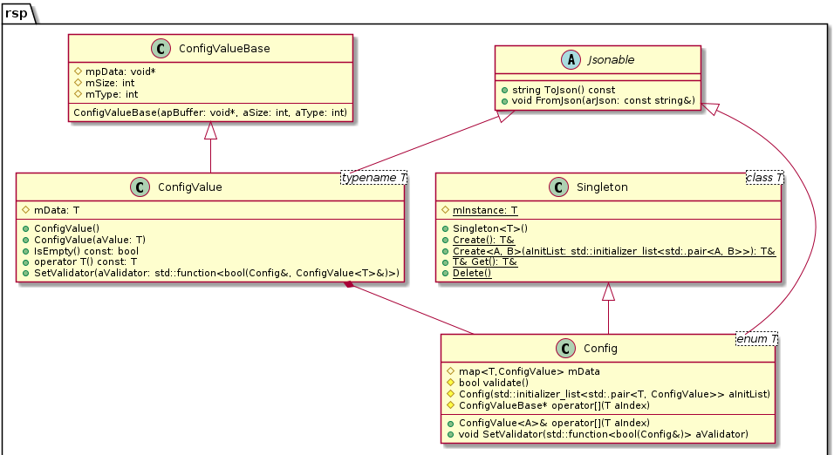Figure 1: Config class and dependencies
Exceptions are thrown when appropriate, by the Config object.

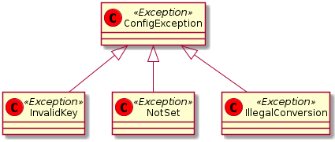Figure 2: Exceptions thrown by configuration module.

Config
The Config class holds the interface for the runtime configuration. It is used to read all configuration values, set values and validate updated configuration.
The Config class has a static Get method to retrieve a singleton instance, which must previously have been created with the static Create method.
The array operator returns a reference to specialized ConfigValue types.

ConfigValueBase
Simply a base class with a pointer to the memory area of the configuration value element.

ConfigValue
Template class for custom value types. It descents from ConfigValueBase which contains a generic memory interface for all values.
The class also implements the Jsonable interface for easy network transfers and file storage.

Exceptions
A few exceptions is thrown on illegal usage, but the configuration interface is very strict in its usage.

Networking
The network components supports a few operations, useful for embedded devices. Only HTTP and DNS operations are implemented.

High Level Design
The network components supports TLS-1.3 encryption standards, with robust error handling in place.
The components is making use of libcurl to do the actual network interaction.
Some helper classes like Json and Crc32 are available for data conversion and validation.

Network Classes
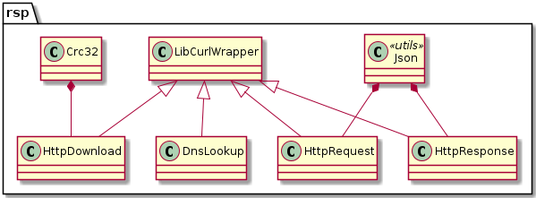Figure 3: Network classes

LibCurlWrapper
A C++ wrapper for libcurl. This could be one of the official C++ wrappers.

HttpRequest
Class with helper functions for easy HTTP requests.

HttpReponse
Class with helper functions for easy response handling.

HttpDownload
Class specialized in file downloads via HTTP. Supports the HTTP RANGE option for continuing interrupted downloads.

DnsLookup
A safe domain name resolver, with timeout and local caching. The resolver makes direct lookups to a given DNS server, this is to avoid problems with error checking system calls like ‘gethostbyname’ and ‘getaddrinfo’.

Localization
Classes for handling text language translation, date and decimal formatting.

High Level Design
The translation class uses id to text map based text lookup. The translation unit expects all text to have a unique numeric ID used to lookup the text in the current language.
When selecting a language, global settings for date and decimal formatting is also changed.
The implementation uses standard C++ std::local::* classes, which again uses POSIX locales and message catalogs.
All translations must be given as POSIX message catalog source files. See more in the Unix manual and in the general programming concepts for the IBM IAX operating system.

Localization Classes

Translation
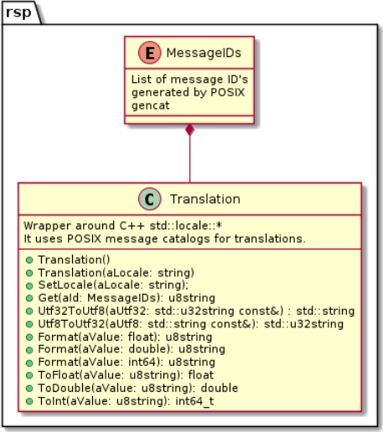Figure 4: Translation class
Class that uses the std::locale framework to lookup text and format numbers and timestamps.

Message ID’s
List of message ID’s, generated by the POSIX ‘gencat’ utility.

Graphical User Interface
The GUI components is intended to be used on a touch screen in a medical device. They support user interaction on the touch screen and give decent layout possibilities for programmers using the library.

GUI Terms
The following terms are used throughout the GUI documentation and code:

Component Any software class used in the GUI
Element Any object placed on a graphical scene. It can be visible or invisible objects, e.g. Button, Label, Image, TouchArea.
Event Signal of some sort of interaction: Touch events are read from a hardware driver, decoded into Press, Move, Release and Click events which are propagated to TouchArea elements.
FPS Frames Per Second, indicates how often information is rendered on screen.
Framebuffer The memory area assigned for pixel data for the screen. It can be larger than the actual screen resolution.
Render Operation used to transfer (draw) the scene content to the framebuffer memory.
Scene Root object for a full screen view. It sets the scenery and can contain many elements.
Screen The physical display device.
View Display of information on the screen. E.g. a single element, multiple widgets in cooperation or an entire scene. A view could render glucose level, battery state or a complex history graph with a built-in calendar selector.
Widget A visible graphical element on the screen, can be an aggregate consisting of multiple elements e.g. Button with TouchArea or a calendar selector.

High Level Design
A design decision was to keep the GUI components simple, powerful and with low CPU and memory requirements.
To achieve this a few design constraints were established early on:
- Every full screen view descends from the Scene class.
- Touchable areas are registered with the Scene object.
- Rendering follows the traditional bottom up principle, with invalidate flag in the components.
- All coordinates are screen coordinates, nothing is relative.
- It is for devices, no built-in support for dynamic resizing and scaling.
- No streaming video support.
This way eventual touch events can be handled very quickly, as touch handlers are directly available.
First rendering of a page should be the slowest operation.
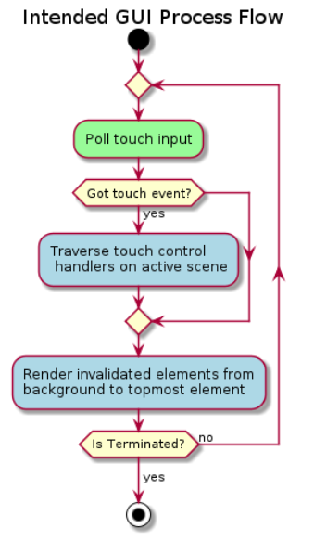

GUI Classes
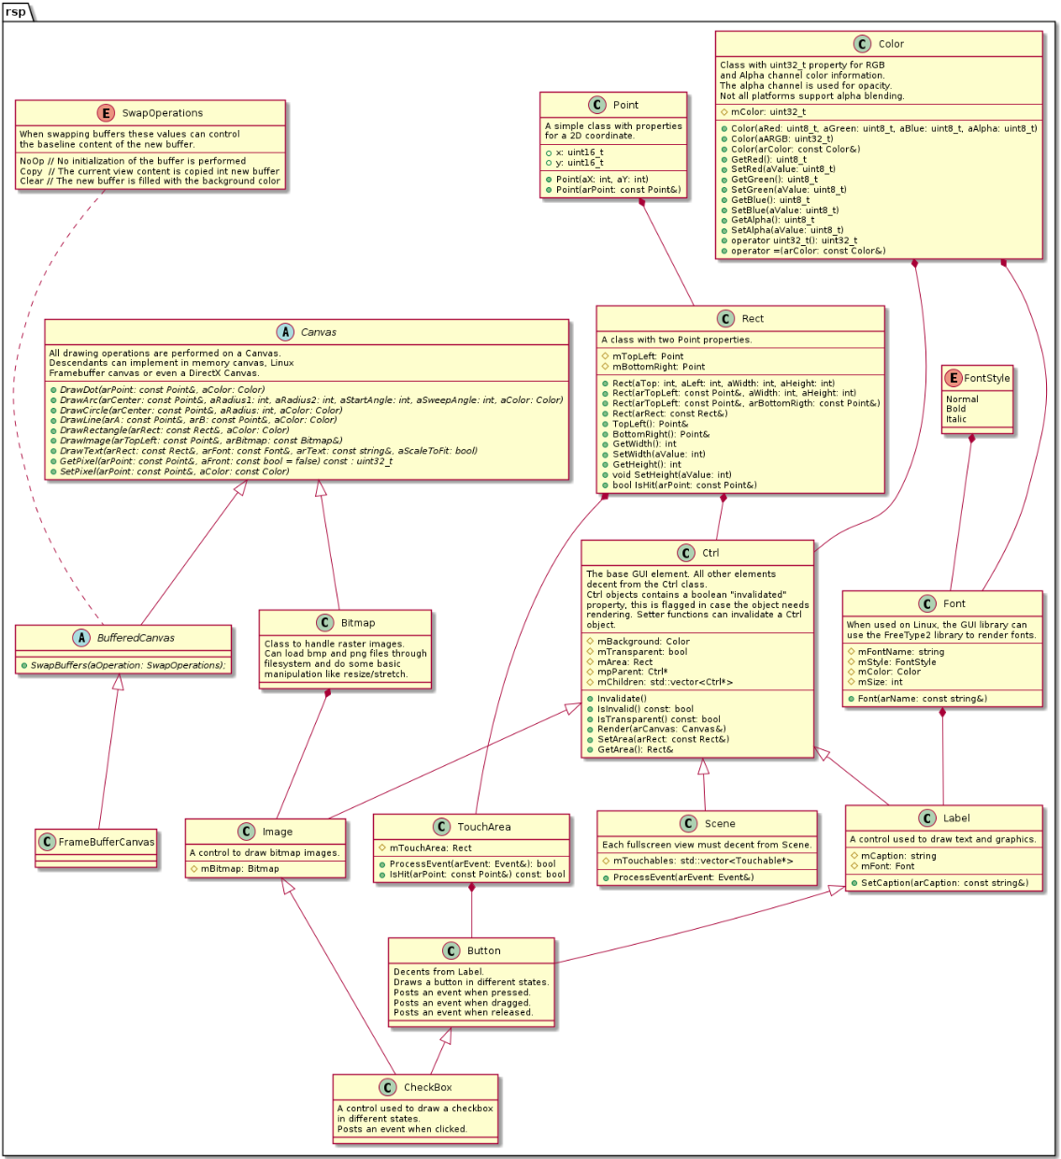

Point
A simple class with properties for a 2D coordinate.

Rect
A class with two Point properties, for TopLeft and BottomRight respectively.

Color
Class with uint32_t property for RGB and Alpha channel color information. The alpha channel is used for blending and transparency. Not all platforms might support alpha blending, but 100% transparency should be possible.

Font
Class with properties for font name, style, color, weight, etc.
When used on Linux, the GUI library can use the FreeType2 library to render fonts.

Bitmap
Class to handle raster images.
Can load BMP files through the filesystem.

Canvas
All drawing operations are performed on a Canvas. Descendants can implement in memory canvas, Linux Framebuffer canvas or even a DirectX Canvas.

Ctrl
The base GUI control class with virtual interface functions for rendering. All other controls descend from the Ctrl class.
Ctrl objects contains a boolean "invalidated" property, this is flagged in case the object needs rendering.

Scene
Each full screen view is a class that descend from Scene. Implements interface functions (Ctrl) to start the touch and paint event propagation. The Scene also sets the background color or image.

Panel
A control to group other controls.

Image
A control to draw bitmap images.

Label
A control used to draw text and graphics.

Button
Descendant from Label. Draws a button in different states.

TouchArea
An invisible element with an area that is responsive to touch events. It is possible to render a boundary rectangle during debugging.
Posts an event when pressed.
Posts an event when dragged.
Posts an event when released.

CheckBox
A control used to draw a checkbox in different states.
Posts an event when clicked.

File System
Besides using the C++17 std::filesystem component, this module also implements useful wrappers around various POSIX file system operations.

File System Classes
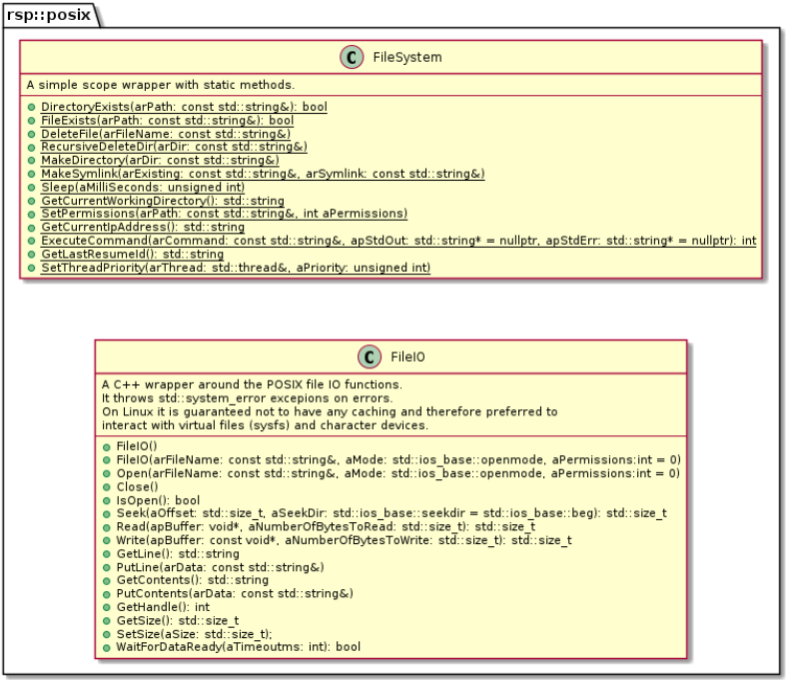Figure 5: POSIX File System Classes

FileSystem
A static class with methods implementing various POSIX file system operations.

FileIO
The Linux POSIX file IO functions are guaranteed to not use any caching, making them the preferred methods for interacting with virtual file handles and character devices.
This class wraps those functions nicely in a C++ object, that throws exceptions on errors, avoiding the need the check the return value of every single call. This makes the final code much more reader friendly and maintainable.

Logging
The logging module was inspired by the thoughts about syslog in RFC-5424 and the PHP PSR-3 Logger Interface specification.

High Level Design
The logging module supports the following:
- All syslog severity levels.
- Multiple runtime attachable log destination handlers (LogWriter derivatives).
- Thread safe logging (local C++ ostream).
- ANSI color coded console output.
- Output to syslogd.
- Output to file.

Logging Classes
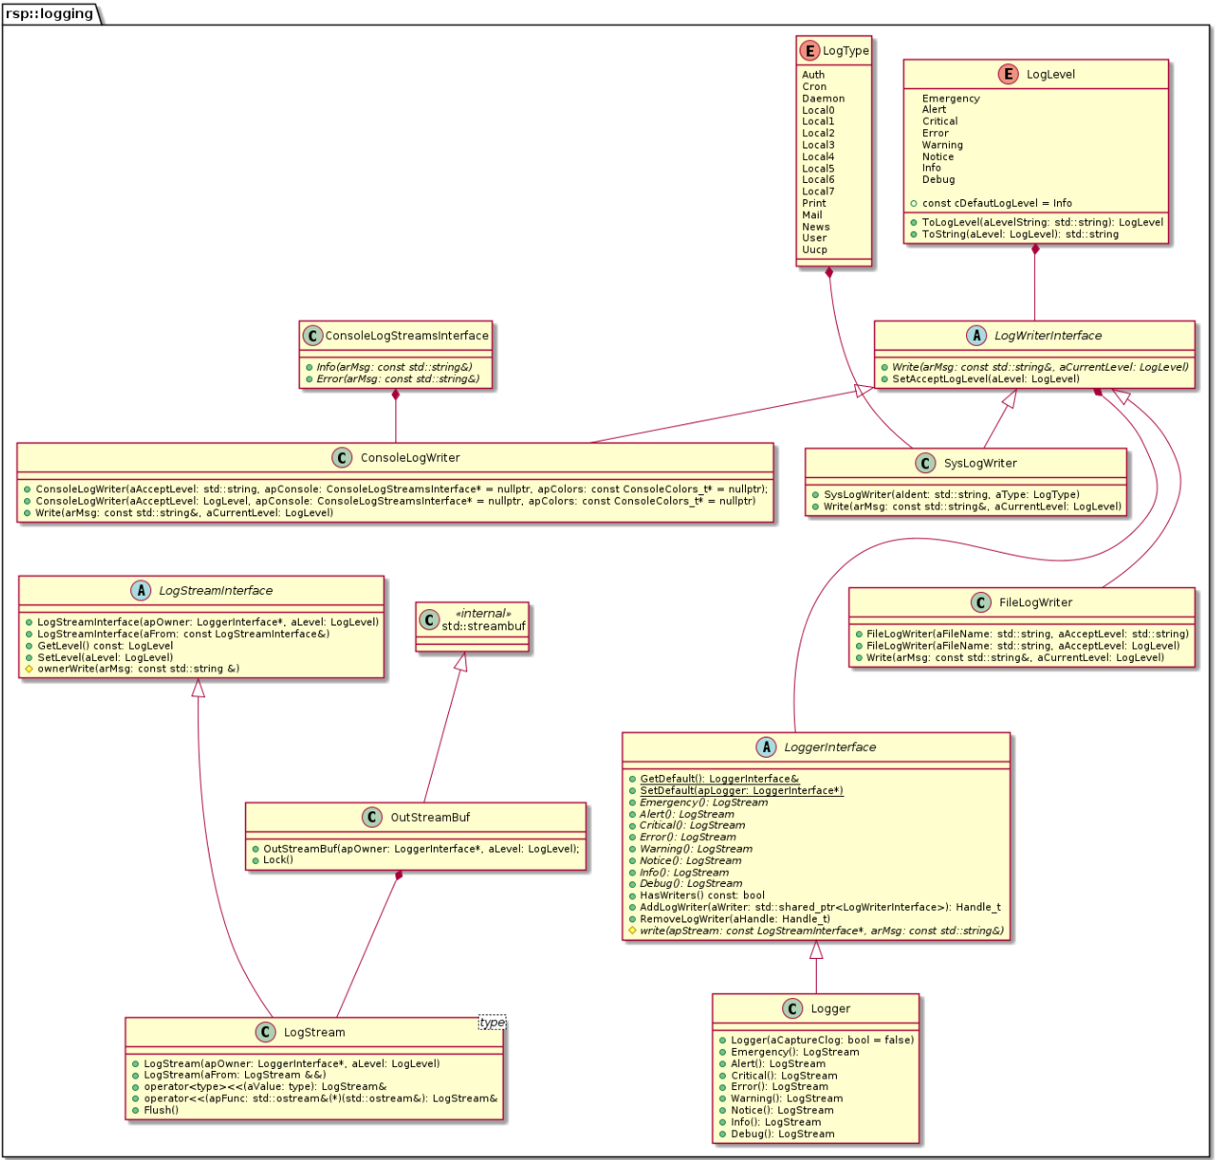Figure 6: Logging classes. With Logger, ConsoleLogWriter and SysLogWriter

Logger
One instance of the Logger class is needed as the application level logging instance. Additional can be created as needed. The logger class can be flagged to redirect std::clog streams, useful if existing code or libraries sends log messages to std::clog.
The LoggerInterface has static getter/setter for an application wide default instance.

LogStream
Normally LogStream instances created using the LoggerInterface abstraction functions named after log level names.
The LogStream instance buffers all streaming content, until it receives an std::flush, the Flush method is directly invoked or the instance is destroyed.
When flushing data a lock guard makes sure the buffer is written to all Logger registered writers at the same time, so different log destinations will see the exact same sequence of log lines. No matter how many threads are logging.

LogWriterInterface
The LogWriterInterface holds only a single abstract write method, that must be implemented if there is a need for a custom logging destination, e.g. a remote logging server.

Utility Classes
The utility classes are a set of C++ solutions for common problems. Ranging from simple string handling, like search for sub strings, comparing and formatting, to advanced decoders like the JSON classes.

AnsiEscapeCodes
A class with predefined ANSI escape codes for terminal colors, cursor movement and special keys.

Nullable
The Nullable interface can be implemented on all types that can be in an invalid state “unassigned”, “empty”, “not set” etc.

StructElement
Template class for structural elements that can be nullable. This is useful if values should be read from a piece of hardware, that is slow or not responding at all, eg. reading a temperature into an integer, either an undefined value or 0 could be the content, both could be a valid temperature. Instead the by using the StructElement<int>, it can now have an unset value, checked via IsNull() or Get() will throw an exception if content is not set.
There is also a Compare function that can compare numeric values with a preset margin, to only detect a change in values of a specified amount, like temperature difference of 1.0, 0.1 or even 0.01°C, but not on simple conversion errors from double to float or noise on some hardware conversion.

Variant
A generic type that can contain any primitive type or a pointer to any complex type.
It has lots of helper methods and operators for easy and safe conversion to other types. Exceptions are thrown if type can not be converted to new type.

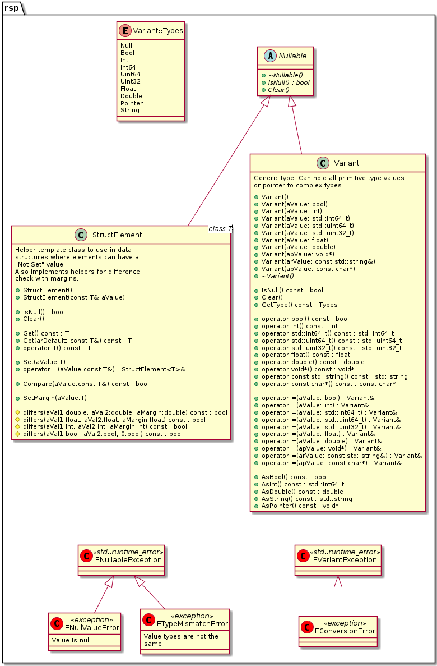Figure 7: Nullable and descendants

JSON
A JSON encoder and decoder. Useful when formatting HTTP REST requests and decoding responses. Exceptions are thrown when decoding illegally formatted JSON strings.
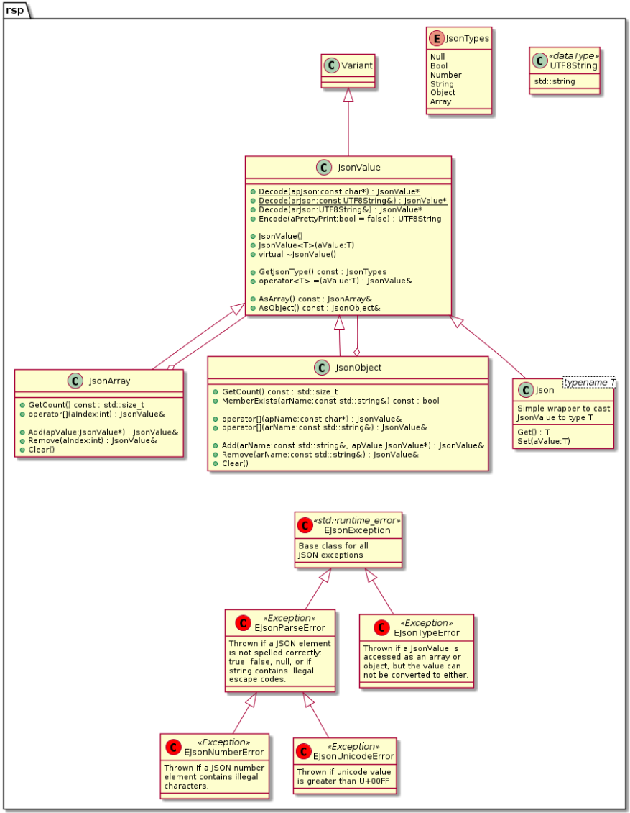Figure 8: JSON classes and exceptions

Crc32
A simple CRC-32 implementation with support for streaming operations.

Singleton
A generic singleton template class, it is not thread safe so initialization must happen before being used by any thread.
The class has a Delete method to destroy the instance, which can be required during automated testing.

References
N/A

Attachments
N/A

Version History
Version | Summary of change | Initials
1.0 | Initial architecture release | SB

